Maintenance Logging in Yardi

Login
YardiOne Dashboard
- Username: concierge@madisongrand.com.au
- Password: Cityroad3006!

Select “CRM Flex”.
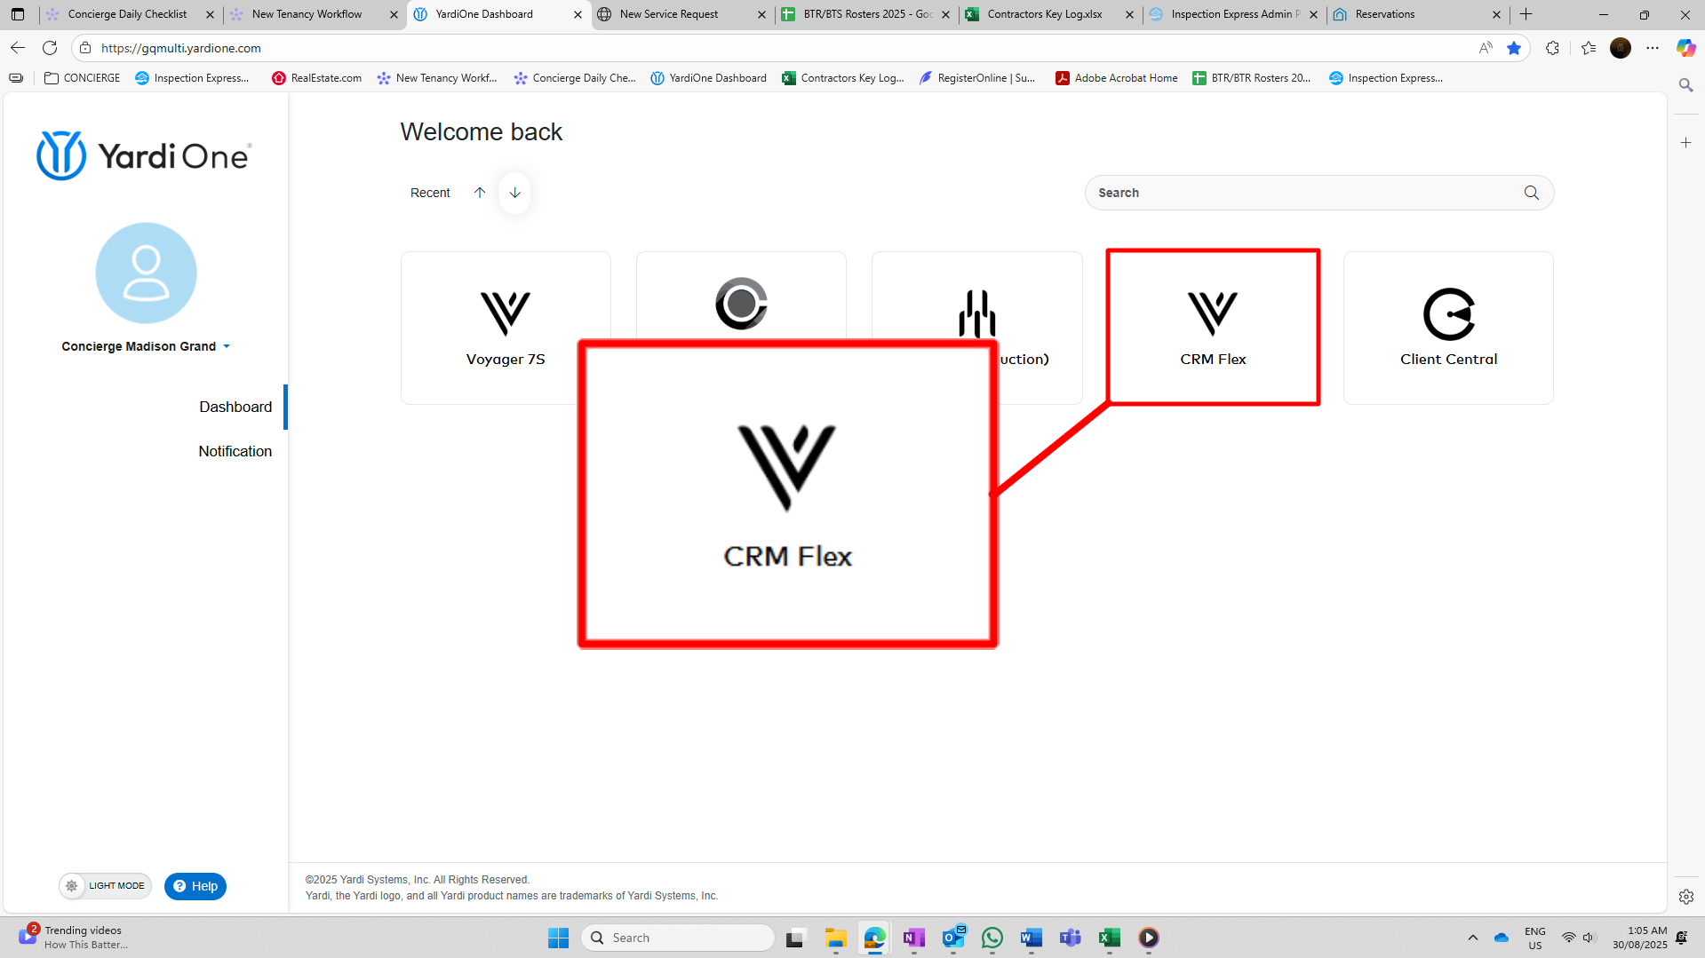

Click “Sign In”.
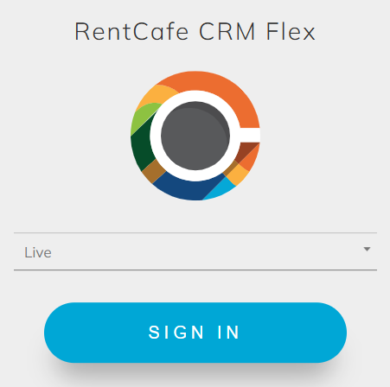

Open the Menu
In the top-right corner select the icon and choose “Yardi Concierge”.
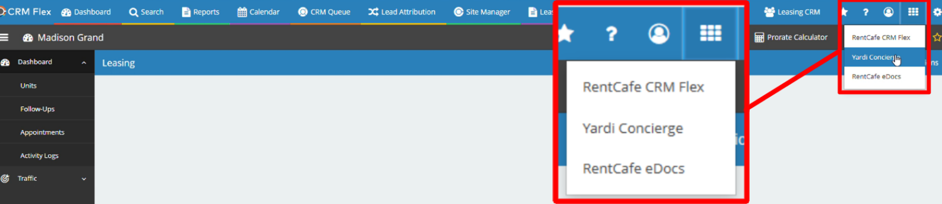

Select the “+” icon
Select the “+” icon in the top-left of the screen.
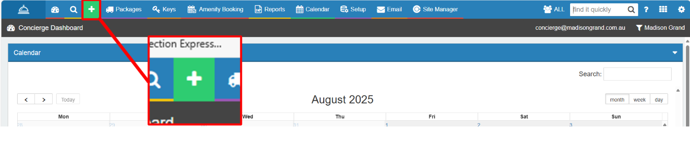

Choose “Service Request”.
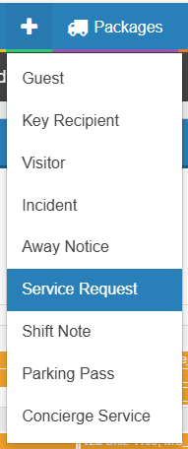

Fill in the required details:
- Property: “Madison Grand”
- Unit # (leave blank if not applicable): Use the dropdown to select the required apartment. Scroll to the bottom and select “More Results” if necessary
- Resident Name: Select the name of the resident who reported the issue
- Category: Select “Management” for maintenance issues
- SubCategory: Select the most relevant subcategory
- Problem Description: Give a brief description of the issue to be resolved
- Priority: Select how important the request is.
Note: Under Victorian tenancy law, urgent repairs are issues that make a property unsafe or uninhabitable and must be fixed immediately. Defined in the Residential Tenancies Act 1997 (Vic) and published by Consumer Affairs Victoria (CAV), urgent repairs include:
- Plumbing – burst pipes, blocked/broken toilet, flooding, serious leaks
- Electrical – dangerous faults, power failures, essential hot water/heating/cooking appliances not working
- Gas – gas leaks, failure of gas supply
- Structural / Building Safety – serious roof leaks, fire or storm damage, insecure premises, severe mould/damp, pest infestations
- Mechanical Systems – lifts or staircases not working, essential cooling/heating failure
- Fire & Safety – smoke alarms not working, pool fences unsafe, failure to meet minimum safety standards
- Toggle “Ok to Enter” (where applicable)
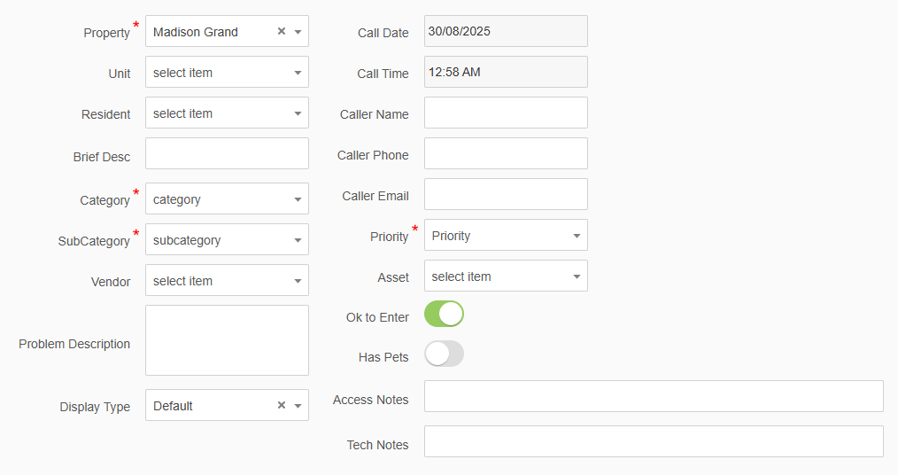

Click “Save”
Select the Save icon in the top right corner of the screen.
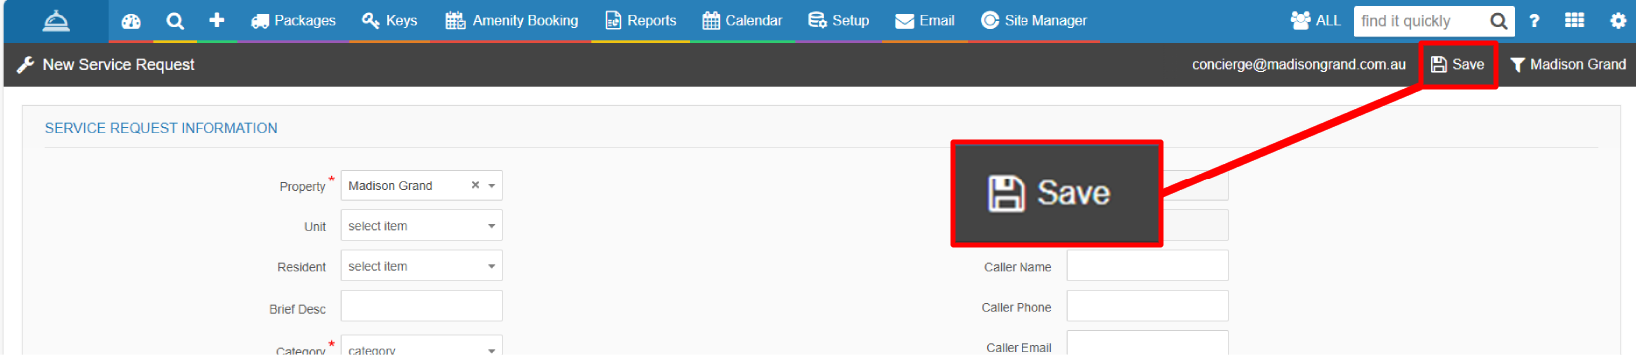

Click “Ok”.
A notification will pop up at the top of the screen confirming the request has been saved.
